**The post will be on the Twitter website:**

Post 1:

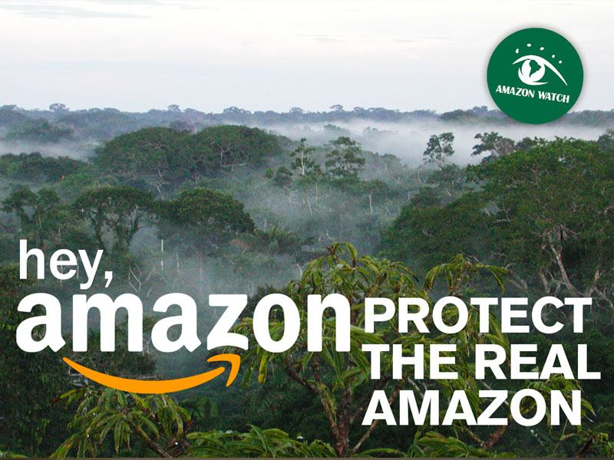

## Did you know that there could be nearly 400 billion trees standing in the Amazon Forest? Help us in saving these trees. Our company, Amazon is very concerned with environmental causes.

## #SaveTheAmazon

Post 2:

## Christmas is around the corner. Have you thought of any good gift to offer to your loved ones? Don’t worry… We got you. Beginning after the 12th of December find more than 10000 products at discounts on our website.

## Don’t forget to spread the good news 😉

## #AmazonChristmas

Post 3:

## Did you know that you have free access and no engagement requirement for Amazon Prime for a whole month? And you? What are some of your tips to save up money this Christmas time?

## #AmazonTipsOfDay

References:

## https://www.google.com/url?sa=i&url=https%3A%2F%2Famazonwatch.org%2Fnews%2F2018%2F0208-why-its-time-for-amazon-com-to-protect-the-real-amazon&psig=AOvVaw3_TqSzTJotLhT-86vAyuLz&ust=1669928385291000&source=images&cd=vfe&ved=0CAMQjB1qFwoTCPCkq5Xm1vsCFQAAAAAdAAAAABAE

## 